The teaching of Maths at Great Bedwyn School 2025-26
Mathematics Statement of Intent
The intent of our mathematics curriculum is provide a mastery curriculum, which is accessible to all and will maximise the development of every child’s ability and academic achievement. We deliver lessons that are creative and engaging and aligned with the nationally recognised White Rose Maths scheme and enriched with support from NCETM support materials. We want children to make rich connections across mathematical ideas through using manipulatives and models and images in every lesson to develop fluency, mathematical reasoning and competence in solving increasingly sophisticated problems. We intend for our pupils to be able to apply their mathematical knowledge to science and other subjects. We want our pupils to realise that mathematics has been developed over centuries, providing the solution to some of history’s most intriguing problems. We want them to know that it is essential to everyday life, critical to science, technology and engineering and necessary for financial literacy and most forms of employment. As our pupils progress, we intend for our pupils to be able to understand the world, have an ability to reason mathematically, have an appreciation of the beauty and power of mathematics, and a sense of enjoyment and curiosity about the subject. 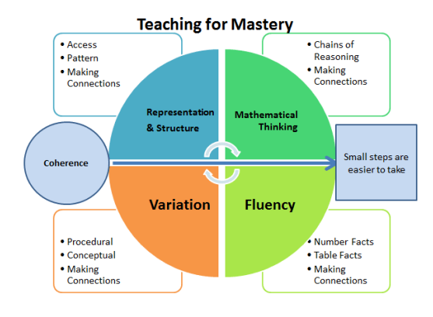

Implementation 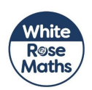
At Great Bedwyn children study mathematics daily following the White Rose Maths small steps. WRM is a set of blocked unit resources which allows for depth and breadth of learning within each strand of mathematics. It is aligned with the government ‘Ready to Progress’ documents.
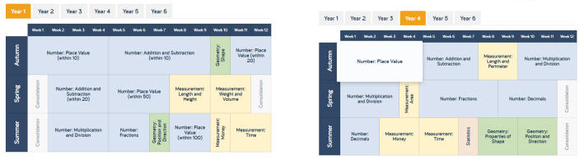
A daily maths lesson (40-60 mins) that is based on the approach and resources from White Rose Maths.
A daily ‘Sticky Maths’ session (10-15 mins) to support the teaching of mental arithmetic- daily practice, chanting number facts, number bonds, times-tables, Five for Five.
All teachers follow the White Rose Small steps, an approach that follows the Shanghai teaching methods of CPA (Concrete- Do It, Pictorial- Twist it. Abstract- Solve it).
Children engage with a wide and varied range of concrete manipulatives, pictorial representations and abstract methodologies within each session. Cohesive use of CPA is a fundamental part of mastery in maths for all learners, not just those pupils with SEND. Concrete and pictorial references scaffold and strengthen understanding and are widely used as a teaching and learning tool from Foundation Stage to Year 6. This is reflected in our adapted Calculations policy.
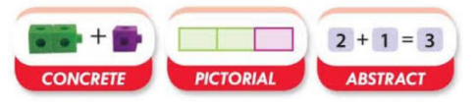
Fluency, Reasoning and problem solving: Every learning session includes the opportunity to develop fluency skills, construct chains of reasoning using relevant knowledge alongside relevant terminology and solve increasingly complex problems in a systematic and coherent way.
KS1- This may be over a week, resulting in a Problem of the week to solve. LKS2 at least 2/3 opportunities to solve problems each week. UKS 2- Daily problem solving.
Mathematical Vocabulary: Sessions include explicit reference to vital mathematical vocabulary and the use of stem sentences to support and encourage all children to communicate their ideas with mathematical precision and clarity. These sentence structures often express key conceptual ideas or generalities and provide a framework to embed conceptual knowledge and build understanding.
Interleaved Learning: WRM is a blocked learning resource and to ensure full coverage of certain strands of maths, as well as returning to areas covered in Lockdown Learning, and areas identified from Gap analysis, we plan and deliver daily interleaved Learning sessions as ‘Sticky Maths’. These are tailored to each cohort’s individual needs and are a combination of mental arithmetic and areas to revisit to ensure fluency.
EYFS- At Great Bedwyn we believe that developing a strong grounding in number is essential so that all children develop the necessary building blocks to excel mathematically. We use a balance of WRM and NCETM and provide children with opportunities to count confidently, develop a deep understanding of the numbers to 10, the relationships between them and the patterns within those numbers. Children have opportunities to build and apply this understanding - such as using manipulatives, including small pebbles and tens frames for organising counting
Our children have clear opportunities to develop their spatial reasoning skills across all areas of mathematics including shape, space and measures through a creative engaging curriculum and environment.

Curriculum Impact
At Great Bedwyn our expectation of a mastery curriculum is that the majority of pupils will achieve Age related Expectations within each year group.
Assessment informs the teaching and learning sequence, and children work on the objectives they are assessed as being at. - Children who not making the required progress are given extra support through booster sessions, interventions, tutoring and support in class in order to meet our INTENT of developing pupils academically. - Feedback is given on children’s learning in line with our feedback policy. Formative assessment within every lesson helps teachers to identify the children who need more support to achieve the intended outcome and same day Post-learning activities can take place. Those who are ready for greater stretch and challenge through planned questioning or additional activities. - In order to support teacher judgments, children are assessed using cold/hot tasks before and at the end of each unit, as well as using current and reliable tests (NFER) in line with the national curriculum for maths. - Analysis of any tests that the children complete is undertaken and fed into future planning.
Summative assessments are completed at the end of the academic year and help influence the overall judgement reported to parents in the end of year report. - The maths leader has a clear role and overall responsibility for the progress of all children in maths throughout school. Working with SLT, key data is analysed and regular feedback is provided and discussed at pupil progress meetings to inform on progress and future actions.

